

**Semester One Examination 2018**

**Question/Answer Booklet**

**MATHEMATICS SPECIALIST**

**UNIT 1**

**Section Two:**

**Calculator-assumed**

Student Name: _____________________________________

Teacher’s Name: _____________________________________

**Time allowed for this section**

Reading time before commencing work: ten minutes

Working time for paper: one hundred minutes

**Material required/recommended for this section**

**To be provided by the supervisor**

This Question/Answer booklet

Formula Sheet (retained from Section One)

**To be provided by the candidate**

Standard items: pens(blue/black preferred), pencils(including coloured), sharpener, correction tape/fluid, erasers, ruler, highlighters

Special Items: drawing instruments, templates, notes on two unfolded sheets of A4 paper, and up to three calculators approved for use in the WACE examinations.

**Important note to candidates**

No other items may be taken into the examination room. It is **your** responsibility to ensure that you do not have any unauthorised notes or other items of a non-personal nature in the examination room. If you have any unauthorised material with you, hand it to the supervisor **before** reading any further.

**Structure of this paper**

|  |  |  |  |  |
| --- | --- | --- | --- | --- |
|  | Number of questions available | Number of questions to be attempted | Suggested working time (minutes) | Marks available |
| Section One  Calculator—free | 7 | 7 | 50 minutes | 50 |
| **Section Two**  **Calculator—assumed** | **12** | **12** | **100 minutes** | **100** |
|  | | | | 150 |

**Instructions to candidates**

1. The rules for the conduct of Western Australian external examinations are detailed in the *Year 12 Information Handbook 2018.* Sitting this examination implies that you agree to abide by these rules.
2. Answer the questions according to the following instructions.

Section Two: Write answers in this Question/Answer Booklet. Answer **all** questions.

**Show all your working clearly.** Your working should be in sufficient detail to allow your

answers to be checked readily and for marks to be awarded for reasoning. Incorrect

answers given without supporting reasoning cannot be allocated any marks. For any

question or part question worth more than two marks, valid working or justification is required to receive full marks. If you repeat an answer to any question, ensure that you cancel the answer you do not wish to have marked.

It is recommended that you **do not use pencil**, except in diagrams.

1. You must be careful to confine your responses to the specific questions asked and to follow any instructions that are specific to a particular question.
2. Spare pages are included at the end of this booklet. They can be used for planning your responses and/or as additional space if required to continue an answer.

* Planning: If you use the spare pages for planning, indicate this clearly at the top of the page.
* Continuing an answer: If you need to use the space to continue an answer, indicate inthe original answer space where the answer is continued, i.e. give the page number. Fill in the number of the question that you are continuing to answer at the top of the page.

1. The Formula Sheet is **not** handed in with your Question/Answer Booklet.

# Section Two: Calculator–assumed 100 marks

This section has **twelve (12)** questions. Attempt **all** questions. Write your answers in the spaces

provided.

Working time: 100 minutes

**Question 8 (5 marks)**

Consider the sets $A=\left\{1, 2, 3, 5, 7, 8\right\}$ and $B=\left\{1, 2, 4, 5, 6, 7\right\}$.

At least one element is chosen from set A, and at least one element is chosen from set B.

(a) What is the minimum number of elements in total that must be chosen to ensure that

there is at least one repeated pair? Clearly justify your answer. (2 marks)

(b) What is the maximum number of elements in total that can be chosen making sure that

their sum does not exceed 30? Clearly justify your answer. (3 marks)

**Question 9 (12 marks)**

A student council of 8 members must be formed from twelve Year 12 students and ten Y11 students.

(a) How many groups of 8 students are possible if:

(i) there are no restrictions? (1 mark)

(ii) it must contain an equal amount of Y11s and Y12s? (2 marks)

(iii) Peter (Y12) will not join if Jake (Y11) is selected? (2 marks)

(iv) Emily and Vicky can only be selected together? (2 marks)

(b) The final group of 8 students, which consists of 5 boys and 3 girls, line up for a photograph.

How many different arrangements are possible if:

(i) no restrictions apply? (1 mark)

(ii) the three girls must stand together? (2 marks)

(iii) Jack and Jake must be separated? (2 marks)

**Question 10 (10 marks)**

(a) Which of the expressions below can be used to calculate the total number of 5-digit PINs

that can be created without repetition of digits? Circle the correct answer(s). (2 marks)

I. ${}_{ }^{10}{C_{5}}$ II. ${{}_{ }^{10}C}_{5}×5!$ III. ${}_{ }^{10}{P_{5}}$ IV. ${}_{ }^{10}{P_{5}}×5!$

(b) 8-character passwords can be created using both lower or upper case letters as well as digits.

Write an expression that would give the total number of 8-character passwords that start with a digit and end with a consonant, and characters are not repeated.

You must use the notation ${}_{ }^{n}{C_{r}}$ and/or ${}_{ }^{n}{P_{r}}$ within your expression. Do not evaluate it.

(3 marks)

(c) Prove that: ${}_{ }^{n}{C_{r}}+{}_{ }^{n}{C_{r+1}}={}_{ }^{n+1}{C_{r+1}}$ (5 marks)

**Question 11 (6 marks)**

The diagram below shows vectors $p$ and $q$ along with a grid created with them.

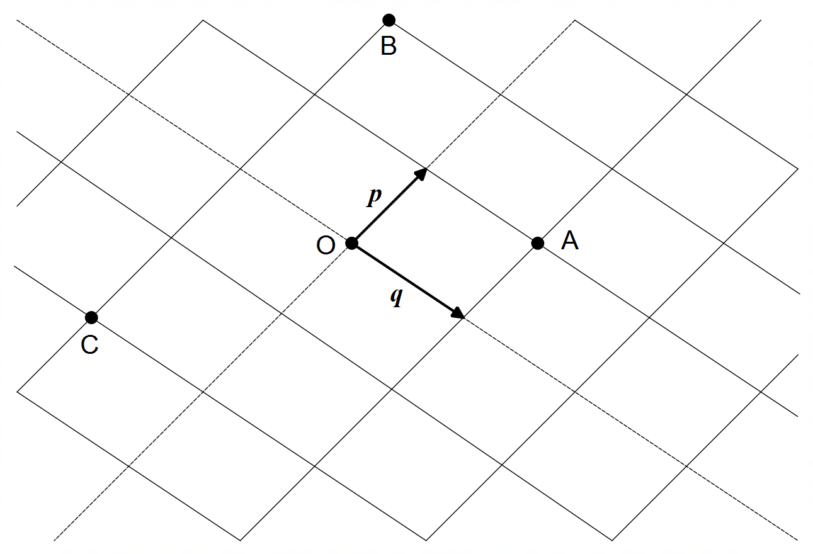

(a) Determine each of the following in terms of **p** and **q**.

(i) $\vec{OA}$ (1 mark)

(ii) $\vec{OB}$ (1 mark)

(iii) $\vec{AC}$ (1 mark)

(iv) $\vec{BA}$ (1 mark)

(b) Clearly mark on the same diagram above the following vectors using O as a reference.

(i) $2q-p$ (1 mark)

(ii) $\frac{5}{2}p+2q$ (1 mark)

**Question 12 (7 marks)**

Let A $\left(-2, 0\right)$, B $\left(1, -3\right)$ and C $\left(2, k\right)$ be the vertices of an isosceles triangle, where AC and BC

are the equal sides, and $k∈R$.

(a) Determine the vectors $\vec{AC}$ and $\vec{BC}$ in component form. (2 marks)

(b) Determine the value of $k$. (2 marks)

(c) Determine the coordinates of D, the midpoint of of AB. (1 mark)

(d) Use the dot product to show that angle CDB is a right angle. (2 marks)

**Question 13 (15 marks)**

(a) Consider the following statements:

P: “The number is divisible by 6”

Q: “The number is divisible by 2”

R: “The number is divisible by 3”

State, with reasons, whether each of the following are true.

(i) P ⇒ Q (2 marks)

(ii) R ⇒ P (2 marks)

(iii) (Q and R) ⇔ P (2 marks)

**Question 13 (Continued)**

(b) Use proof by contradiction to show that if $n$ is even, then $3n+5$ is odd. (5 marks)

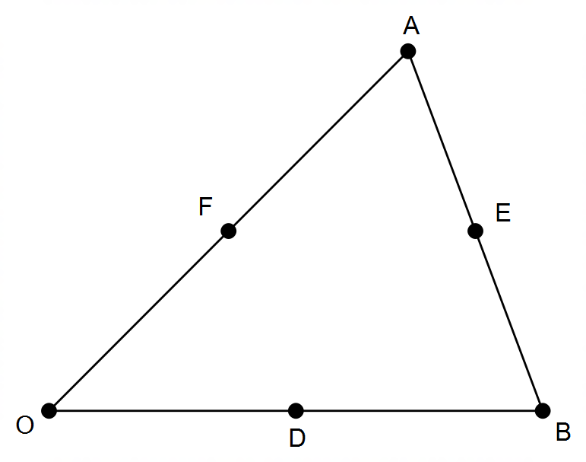

(c)In the diagram shown, $D, E$ and $F$ are midpoints

of the sides of the triangle $OAB$.

Let $a=\vec{OA}$ and $b=\vec{OB}$.

Use vectors to prove that $\vec{OE}+\vec{AD}+\vec{BF}=0$,

where $0$ is the null vector.

(4 marks)

**Question 14 (12 marks)**

The diagram below represents a weight of 250 N suspended from two cables.

The cables are attached to the ceiling and hold the weight at different angles as shown.

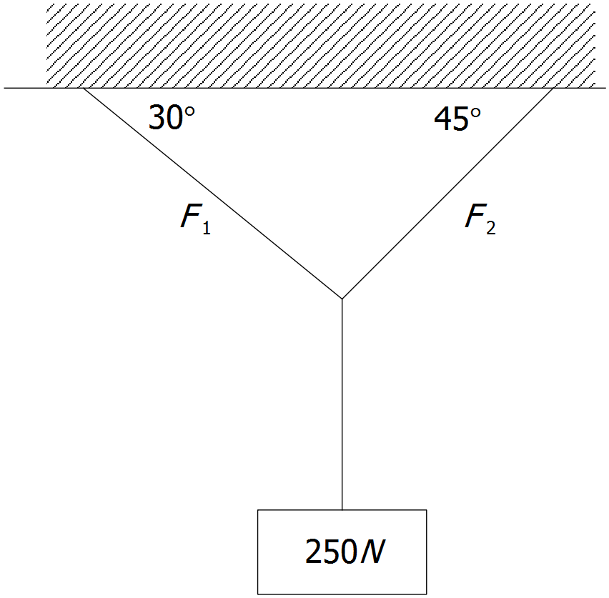

Assuming that the system is in equilibrium (the net resultant force is zero, i.e. no motion), the diagram above can be simplified into the vector diagram shown below.

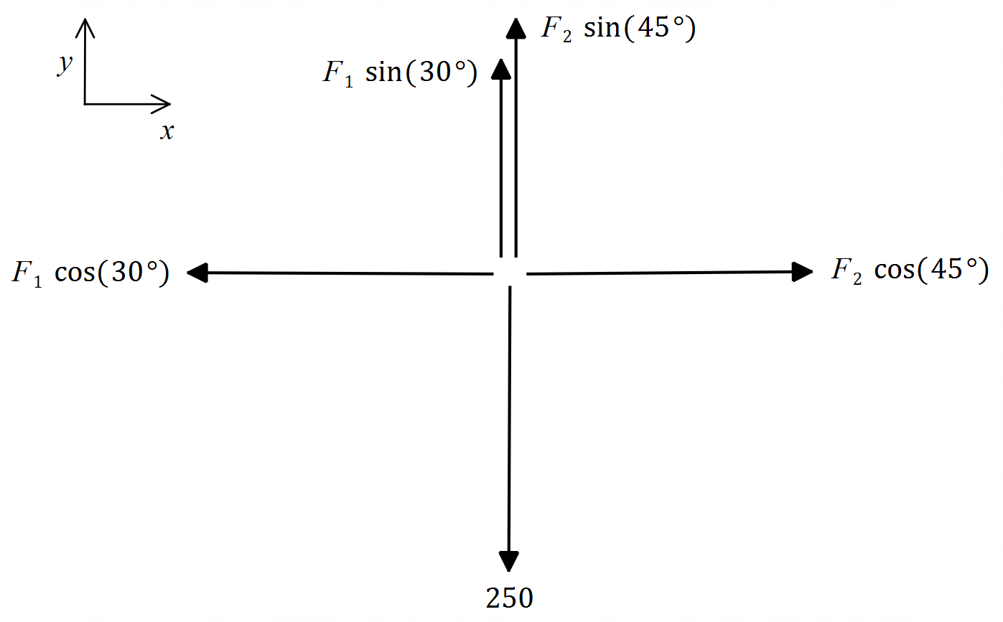

**Question 14 (Continued)**

(a) Given that the system is in equilibrium, set up two equations from the vector diagram given,

one along the x-axis and one along the y-axis. (2 marks)

(b) Using your equations from (a), determine *F1* and *F*2, the forces exerted along each cable

by the 250N weight, correct to **two (2)** decimal places. Show working for full marks. (4 marks)

**Question 14 (Continued)**

(c) If the cables can support a maximum tensile force of 200 N each (i.e. F1,max = F2,max = 200N),

what is the maximum weight that can be suspended in this set up?

[Hint: Assume that only one of the cables is at its maximum tensile force, not both.] (6 marks)

**Question 15 (6 marks)**

Local councils require homeowners to register their pets, and the law covers mainly dogs and cats.

A survey of 1 000 households in the local council found that 400 homes had dogs registered, 500 had cats registered and 190 had neither.

(a) Show how to use the inclusion-exclusion principle for two-sets to determine the number of homes surveyed that contain both dogs and cats. (3 marks)

The council decided to include exotic birds into their pet registry to increase control and standards.

The same survey found that 210 homes had exotic birds, 90 had both dogs and cats, 60 had both dogs and exotic birds and 110 had both cats and exotic birds. 100 homes had none of these.

(b) Show how to use the inclusion-exclusion principle for three-sets to determine the number of homes surveyed that contain dogs, cats and exotic birds. (3 marks)

**Question 16 (8 marks)**

In Pascal’s triangle, the squares of the elements in Column 1 can be obtained by adding the two adjacent elements from Column 2. Two such examples are shown on the diagram below.

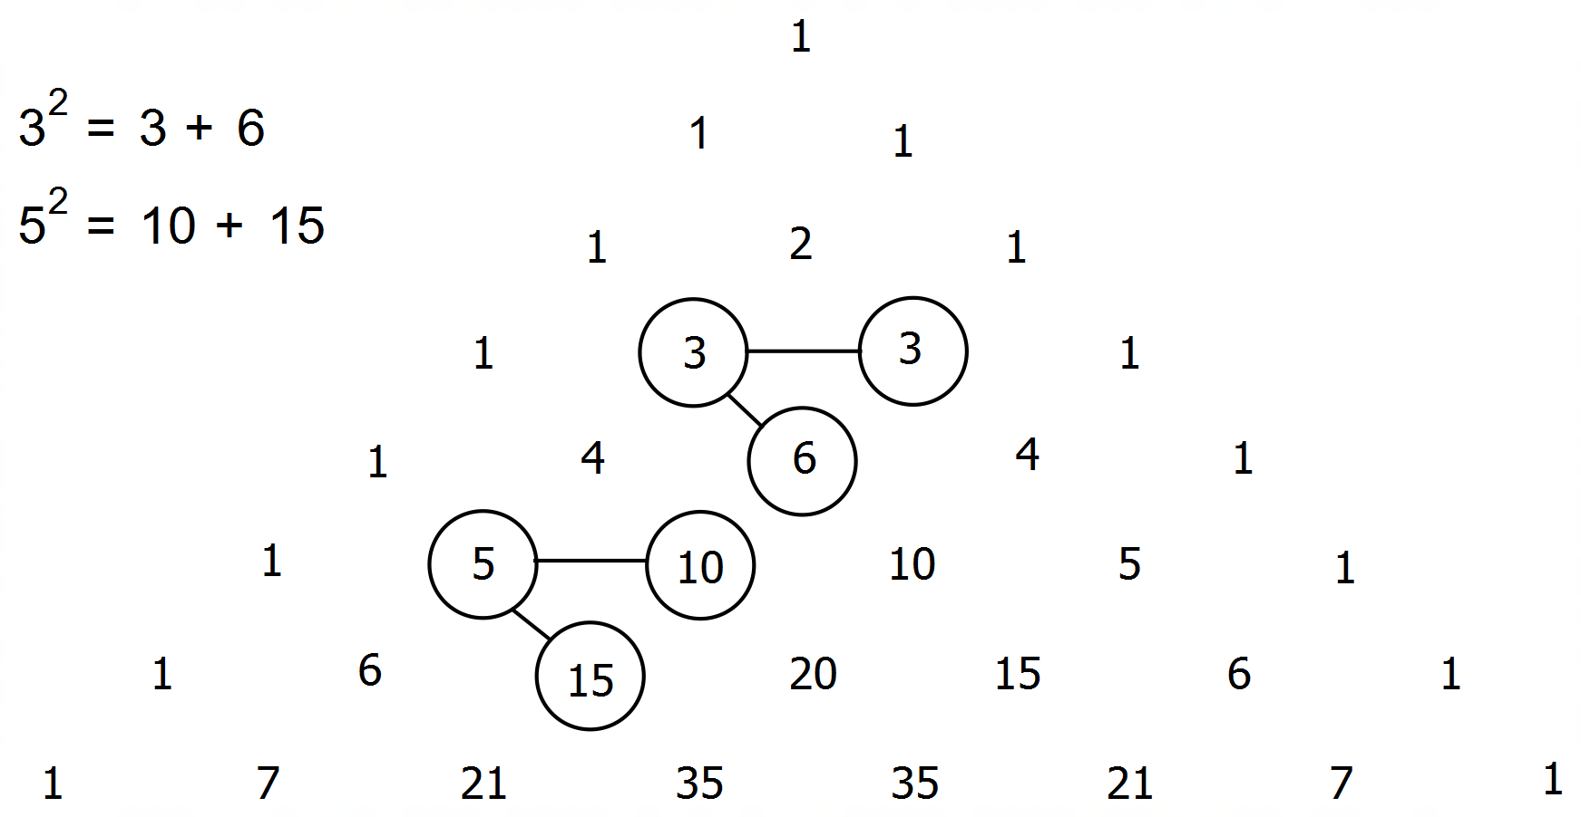

Any number in Pascal’s triangle can be represented by ${}_{ }^{n}{C_{r}}$, where $n$ and $r$ represent the horizontal row and diagonal (column) position respectively beginning at zero.

(a) Write the two examples given above using the notation ${}_{ }^{n}{C_{r}}$. (2 marks)

(b) The expression below represents this relationship for any number in the first column.

State $a$ and $b$ in terms of $n$ and/or $r$ as needed. (2 marks)

$${\left({}_{ }^{n}{C_{1}}\right)}^{2}={}_{ }^{n}{C_{a}}+{}_{ }^{b}{C_{a}}$$

**Question 16 (Continued)**

The squares of the elements in Column 1 can also be obtained by subtracting two respective elements from Column 3. Two such examples are shown on the diagram below.

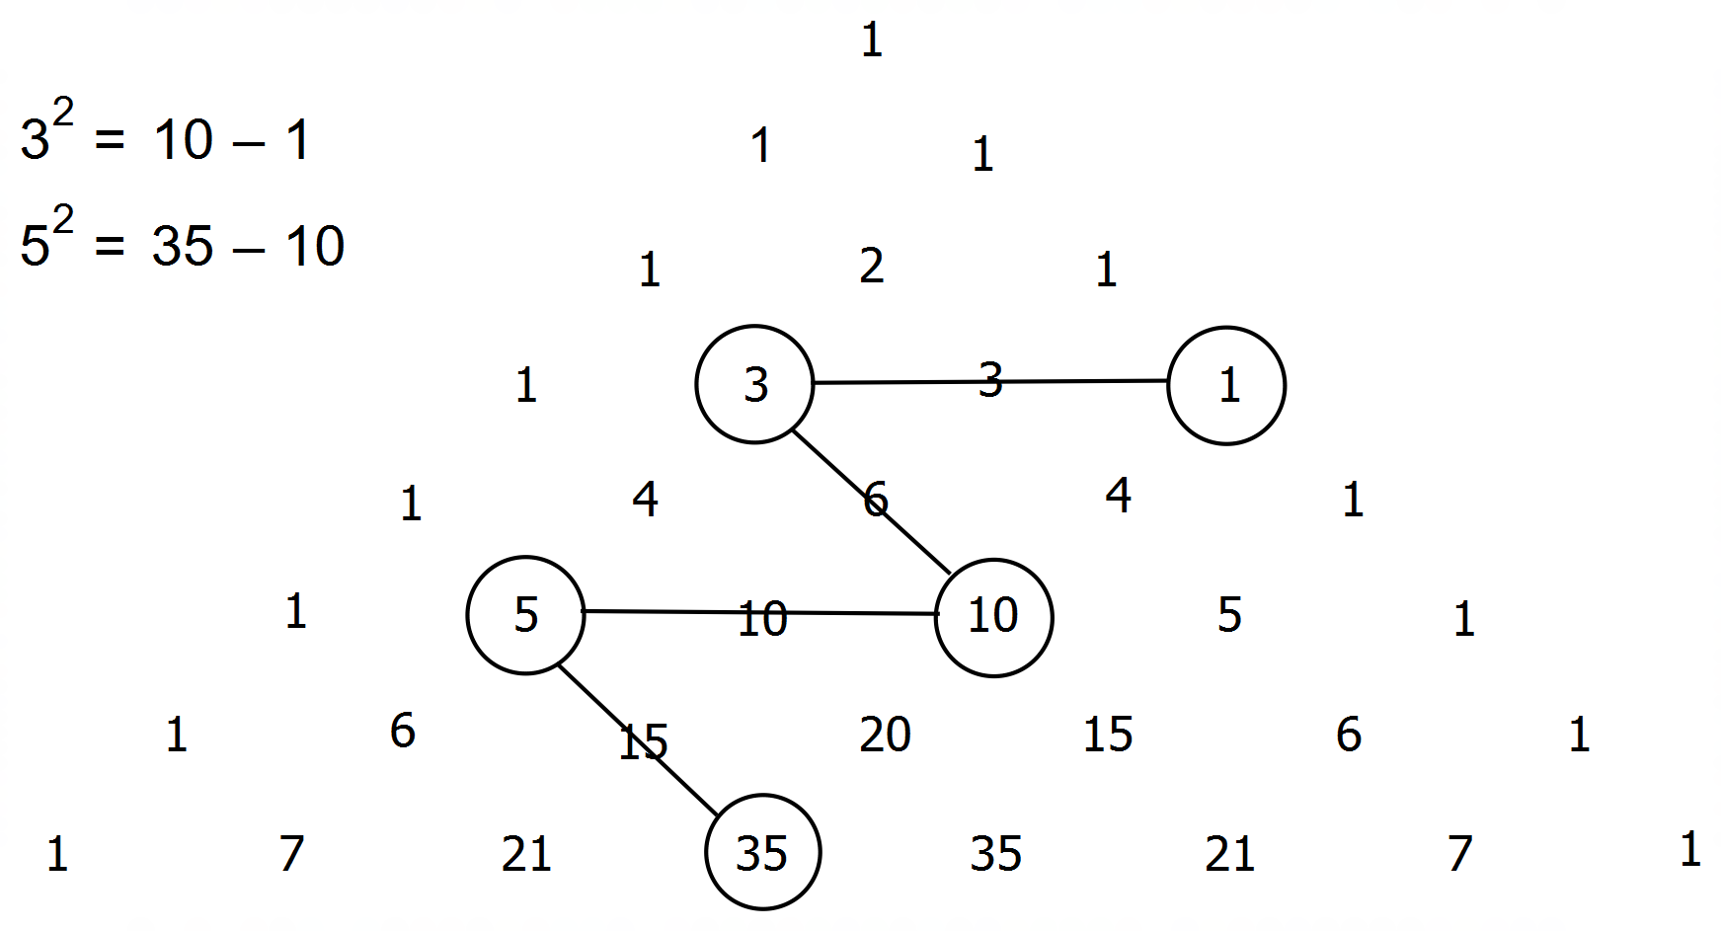

(c) Complete the expression below using the notation ${}_{ }^{n}{C_{r}}$. (2 marks)

${\left({}_{ }^{6}{C_{1}}\right)}^{2}=$

(d) Write a generic expression for the square of any number in Column 1 using

the notation ${}_{ }^{n}{C_{r}}$. (2 marks)

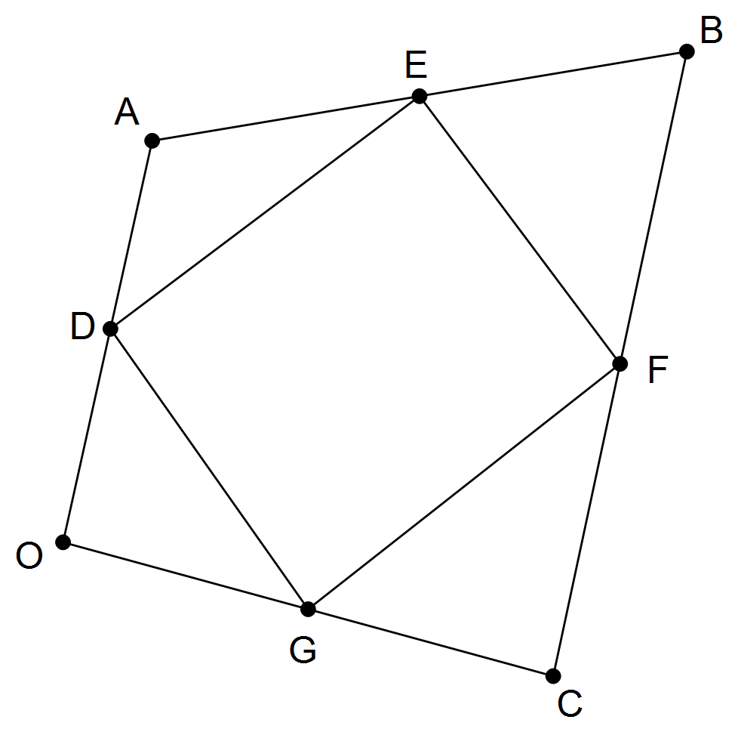**Question 17 (7 marks)**

The diagram shows quadrilateral OABC, where

points D, E , F and G are the midpoints of sides

OA, AB, BC and OC respectively.

Let $\vec{OA}=a$**, $\vec{OB}=b$**  and $\vec{OC}=c$.

(a) Determine $\vec{OE}$ and $\vec{OF}$ in terms of $a, b$ and/or $c$.

(2 marks)

(b) Show that quadrilateral DEFG is a parallelogram. (5 marks)

**Question 18 (6 marks)**

Determine the value of the pronumerals *x*, *y* and *z* in the diagram below.

Show working for full marks. (6 marks)

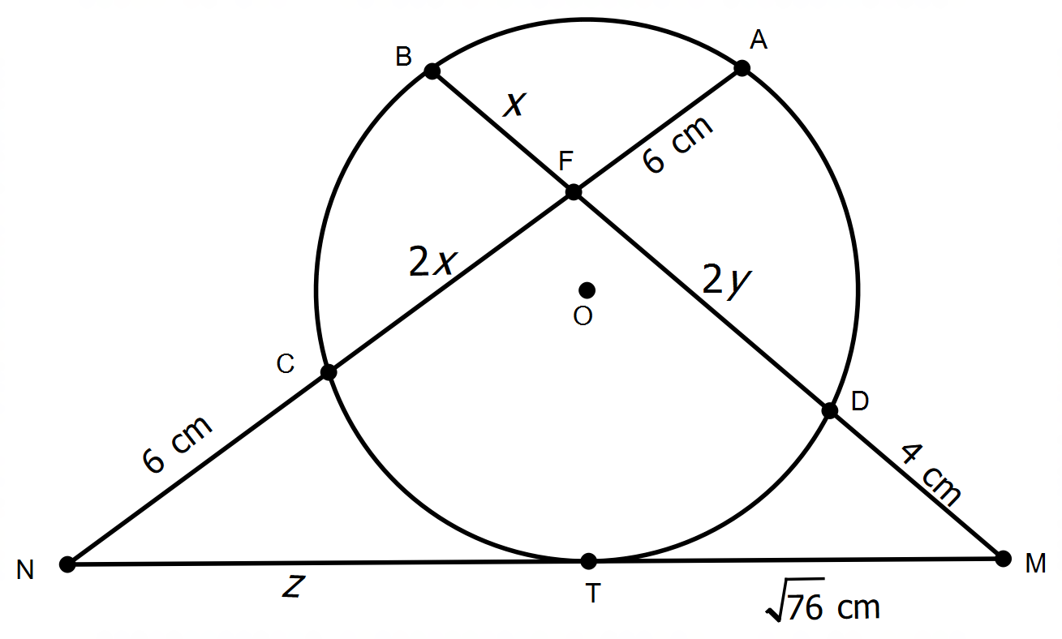

|BF| = x

|FD| = 2y

|CF| = 2x

|FA| = 6 cm

|DM| = 4 cm

|TM| = 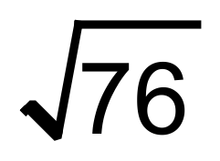 cm

|NC| = 6 cm

|NT| = z

**Question 19 (6 marks)**

The diagram below shows vectors $a=\left(\begin{matrix}x \\ y\end{matrix}\right), b=\left(\begin{matrix}4 \\ 2\end{matrix}\right)$ and $u=\left(\begin{matrix}3 \\ 1.5\end{matrix}\right)$ where $x,y∈R$.

The angle between $a$ and $b$ is $60°$.

Given that $u$ is the projection of $a$ onto $b$, determine the exact value(s) of $x$ and $y$.

$$60°$$

$$a$$

$$u$$

$$b$$

(6 marks)

**END OF QUESTIONS**

**Additional working space**

Question number(s): ……………………

**Additional working space**

Question number(s): ……………………